Natural Selection and the Peppered Moth

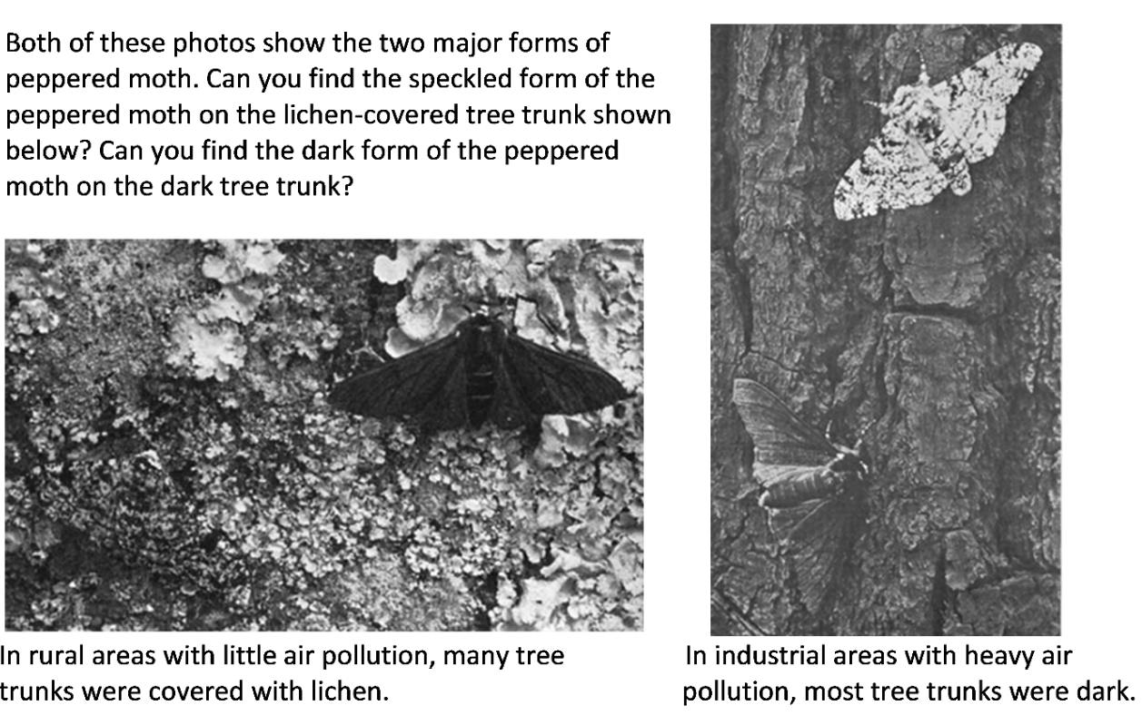
Peppered moths are active at night. During the day, they rest on tree trunks and branches. Some of these resting peppered moths are eaten by birds. Researchers have observed differences in mortality in the two environments shown above. One form of the peppered moth survived better in one of the environments and the other form of the peppered moth survived better in the other environment.

1. In each photo, circle the form of the peppered moth that would have higher mortality in that environment.

An individual peppered moth cannot change from speckled to dark or vice versa. The difference between the speckled and dark forms of the peppered moth is a heritable trait. Specifically, this difference results from different alleles of a single gene. The allele for the dark form (D) is dominant over the allele for the speckled form (d).

2a. Complete these Punnett squares. Circle the genotype of each parent or offspring that would have the dark form. Put an * next to the genotype of each parent or offspring that would have the speckled form.

2b. Explain why the offspring of peppered moths generally look like their parents.

3. Complete this table to give evidence that the peppered moth example fulfills each condition needed for evolution by natural selection to occur.

Necessary Conditions for Evolution by Natural Selection to Occur | What is the evidence that the peppered moth example  fulfills each necessary condition?
There must be variation in a trait.
The variation in the trait must result in differences in fitness. (Fitness is the ability to survive and reproduce.)
The variation in the trait must be heritable.

4. Complete this table to describe the expected effects of natural selection as the environment changed in regions of England that became industrialized.

Environmental Change for Industrialized Regions  of England | Expected Effects of  Natural Selection on  % Dark Peppered Moths | Expected Trends in % D Alleles  (for the D/d gene that determines the dark vs. speckled form)
Before 1850, air pollution was low and tree trunks and branches were lighter and often covered with lichen. | The dark form of the peppered moth was more likely to be eaten by birds, so the dark form had low fitness and was very rare. | Moths with the D allele are dark. In this environment, dark moths rarely survived to reproduce. Therefore, the D allele was very rare.
After 1850, industrialization resulted in air pollution which darkened tree trunks and branches. | Decrease ___  Increase ___  Stay the same ___ | Decrease ___  Increase ___  Stay the same ___
Beginning in the late 1950s, government regulation resulted in decreased air pollution, so tree trunks and branches became lighter. | Decrease ___  Increase ___  Stay the same ___ | Decrease ___  Increase ___  Stay the same ___

These graphs show trends in the percent dark moths and the percent D alleles in an industrialized region in England. Each dot in the upper graph represents a data point. The lines show the estimated trends. (The width of each line indicates uncertainty in the estimates.)  5a. Do these graphs support your predictions in question 4?  yes ___ partly ___ no ___  5b. Explain the causes of any trends that are different from your predictions. | 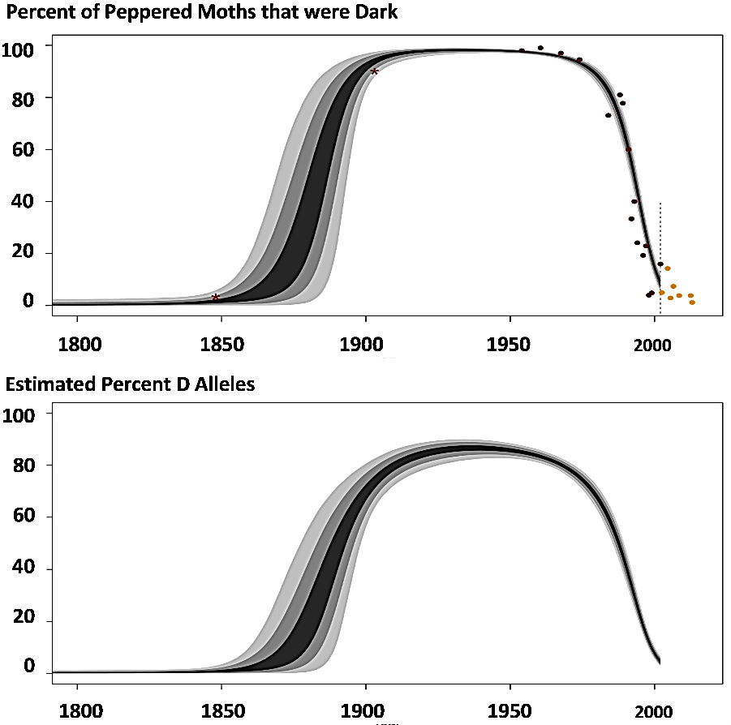

6. A student wrote this paragraph to explain the causes of these trends.
During industrialization, air pollution resulted in dark tree trunks and branches. Most of the peppered moths became dark, because the peppered moths needed to be dark so they would not be seen and eaten by birds. Then air pollution decreased, so tree trunks and branches became lighter, so the peppered moths became lighter so they would not be eaten by birds.

Write a scientifically more accurate explanation of what happened to cause the trends in the graph. (A complete answer will include camouflage, fitness, and natural selection.)

7. In this graph, predict the trend in the percent of peppered moths that were dark in non-industrialized rural regions. Explain your reasoning. | 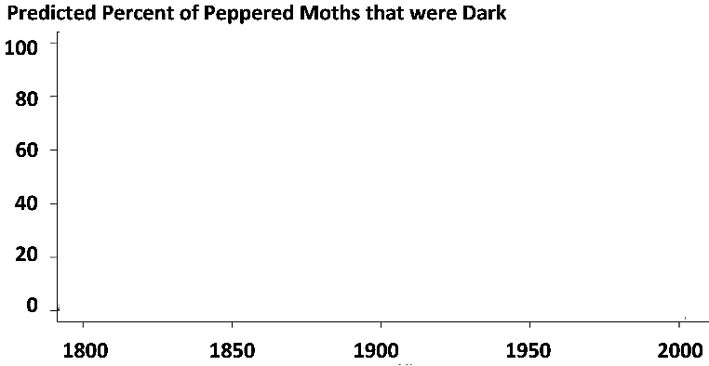

During the second half of the twentieth century, similar trends were observed in industrialized regions in England and the US.  Air pollution decreased and the percent of peppered moths that were dark decreased.  In rural regions, air pollution remained low and dark peppered moths were rare throughout this time period. | 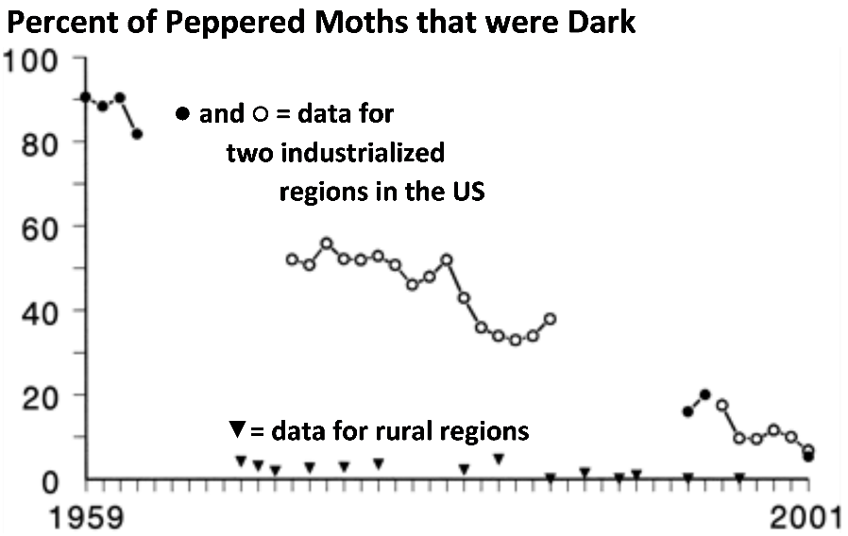

8a. Was natural selection occurring in the rural regions? yes ___ no ___

8b. Explain your reasoning.

Scientists have observed multiple additional examples of natural selection in action. For example, natural selection has increased antibiotic resistance in many types of bacteria, and natural selection has increased resistance to pesticides in many types of insects.

9a. Many people think of the process of evolution as "survival of the fittest". How do you think most people interpret "survival of the fittest"?

9b. How do biologists define fitness?

9c. What are some examples of characteristics that contribute to fitness?

10. Explain how the peppered moth example illustrates the following general principles.

A. Natural selection acts on individuals, but only populations evolve.

B. Natural selection acts on phenotypes, but natural selection results in changes in allele frequencies.

By Dr. Ingrid Waldron, Dept Biology, University of Pennsylvania. © 2024. A Word file and Teacher Preparation Notes with instructional suggestions and biology background are available at https://serendipstudio.org/exchange/bioactivities/NaturalSelectionMoth.

